CULLIGAN
PURITY ESSENTIAL

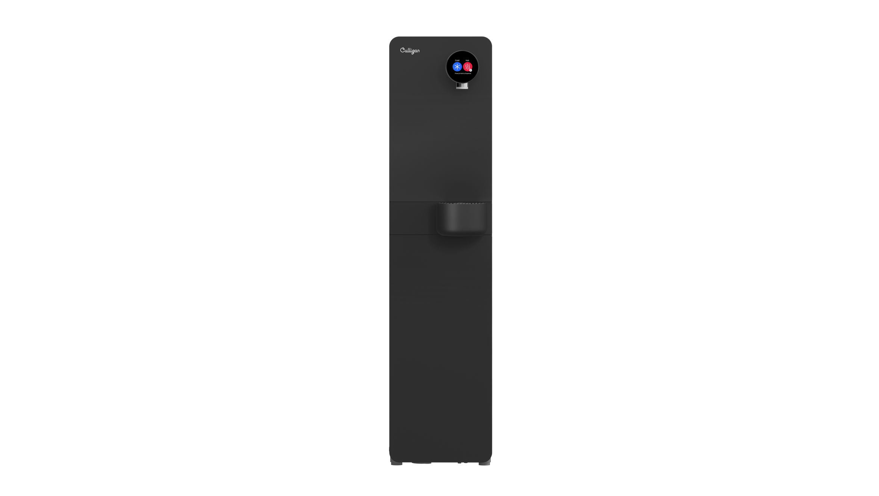
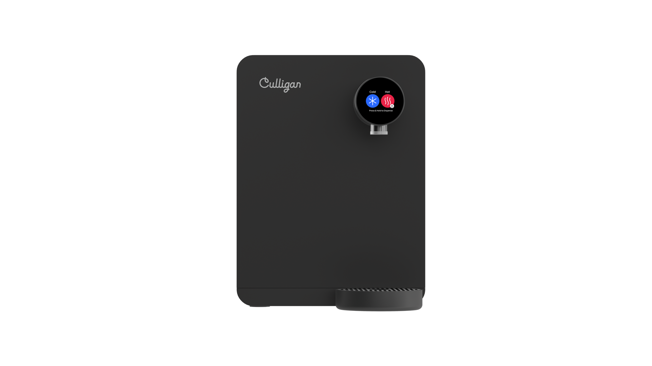
User Manual
Floor Standing & Countertop
Rev. 1.0 – 08/2025
Warnings
Before using this machine, please read this manual. Please follow the instructions for proper operation and to prevent risk and damage. This manual is part of the product. It contains important information on safety as well as the installation, use and disposal of the product. Please familiarize yourself with all the included information before using the product. The product may only be used as described in this manual.
Ensure all local laws and codes including health and safety guidelines are met when installing this Culligan purification system. Only qualified service technicians should attempt installation and service. Always read the entire operating instructions before using the appliance and save these instructions for future use.
Use grounded power socket with correct voltage.
To reduce risk of injury and property damage, user must read this entire guide before installing and using this dispenser. Failure to execute the instructions in this manual may result in personal injury or damage to property. When operating this dispenser always exercise basic safety precautions including the following:
Prior to use, this dispenser must be installed in accordance with this manual.
This dispenser is intended for potable water dispensing only. Do NOT use other liquids. Never use any liquid in the dispenser other than known and microbiologically safe water.
Do not use if plug or cable are damaged.
The power cord should be positioned so that it is not likely to be pinched, shrunk, walked on, kinked, wetted or tripped over.
If the power cord is damaged, it must be replaced by the manufacturer, its maintenance department or similar professionals to avoid danger.
The appliance must be protected by a residual current device (RCD).
Never unplug by pulling power cable, always hold the plug.
The disconnection of the electrical supply must be possible either by unplugging the plug or by means of a two-pole mains switch placed upstream of the socket.
Check that the voltage on the rating plate corresponds to that of the installation location.
To protect against electric shock, do not immerse plug or cable in water or any other liquid. Do not operate with wet hands.
Do not install the unit close of sources of ignition.
Any malfunction of the systems must be promptly reported to the Culligan Customer Service, immediately discontinuing use of the system.
Culligan is not responsible for the consequences of continued use of a system that has shown anomalies.
This appliance is not intended to be used by individuals (including children) with reduced physical, sensory or mental capabilities, or who lack experience and knowledge, unless they are under supervision or have been instructed to use the appliance by an individual responsible for their safety.
Children should be supervised to ensure that they do not play with the appliance.

Never leave the product unattended when children and/or animals are around. The product may be put out of balance and may fall, hurt or in worst case even cause fatal injuries.

Mount the product on a floor stand that meets the minimum requirements for stability. Do not place the system on top of other appliances.

Do not place other electrical appliances in the immediate vicinity of the water dispenser. Keep the areas around the product dry to prevent people from slipping on wet surfaces.

Warnings during installation

- Ensure all Local, State, and Federal Laws and Codes including health and safety guidelines are met when installing Culligan Equipment. Only qualified service technicians should attempt installation and service of Culligan Equipment.
- The product can be installed in the following places: indoor environment.
- Do not place objects on the water dispenser.
- The installation must be carried out only by qualified and authorized personnel, and with the best state of the art in compliance with what is reported in the technical manual.
- Do not place the dispenser on other objects.
- Check that the machine is well levelled and that it rests on a floor or surface capable of supporting its weight and in an environment suitable for its size and use.
- Before any maintenance or cleaning operation, unplug the machine from the power outlet or disconnect the power supply.
- Installation in outdoor environments exposed to rain or snow is prohibited. Check all relevant parameters (ambient temperature, electricity, water mains pressure) before installation, making sure that all parameters are in line with the technical requirements of the product and in line with the applicable local regulations.
- The machine is not suitable for installation where there are jets of water for cleaning.
- Do not place the machine near sources of heat, flames or the like and damp surfaces
- The dispenser must be placed on a flat, level and dry surface with an adequate capacity for the weight of the product.
- Maximum temperature of the installation environment 32 °C and keep the unit away from humidity levels above 60%.

The area chosen for installation must be clean, dry and ventilated, with the equipment placed away from heat sources.

WARNING: during handling or maintenance, always keep the machine in a vertical position. The machine can only be tilted to the rear. Do not tilt or lay the machine on its right, left or front side. This operation could compromise the operation of the compressor.

WARNING: electrical shock hazard. Always unplug (isolate from power supply) to prevent electrical shock except where electrical tests are specified.

WARNING: improper supply or connection can result in risk of shock. Always use a dedicated and properly earthed outlet. Unit should be protected by ground-fault circuit interrupter and residual current device (RCD) having a rated residual operating current not exceeding 30 mA;

WARNING: use only Culligan supplied power cord. Locate system within 1m of power supply. Never use an extension cord or adapter. Do not use a damaged power cord or plug. Keep power cord out of heavy traffic areas and away from heat sources. Do not, under any circumstances, remove ground prong or alter the power cord. Never pull the power plug from the outlet with a wet hand or allow the plug to get wet.

WARNING: use a water pressure regulator. Culligan will not be responsible for injury or damage caused by excessive water pressure. Operating pressure must be 1 Bar to 3 Bar (14.5 psi to 43.5 psi – 0.1MPa to 0.3MPa).

WARNING: use UV stabilized supply lines. Feed the unit with a potable ambient or cold water supply only. Feed water over 37ºC (98.6ºF) can damage the treatment components. Water block device is strongly recommended. Locate the unit as close to the water supply and the electrical connections as possible.

WARNING: UV-C emitter (UV Lamp): this appliance contains a UV-C emitter (UV Lamp). UV-C radiation may, even in little doses, cause harm to the eyes and skin. Never operate the UV-C emitter if damaged or removed from enclosure. Do not touch or look directly into the faucet. The replacement of the UV-C must be done by Culligan or approved Culligan distributors and with power supply disconnected.

WARNING: hot water: Culligan machines produces hot water (model dependent) above 52°C and up to 92°C which can cause severe burns or scalding. Keep unauthorized people and children away from the unit to avoid accidental dispensing of hot water.

WARNING: store unit empty. Always sanitize before use.
The unit must be completely drained and sealed before storing to avoid stagnation and reduce microbiological contamination (potential bacterial growth). Sanitize before use to eliminate any potential microbiological contaminants.

Environmental characteristics
The intended operating environment must have the following characteristics:
- Temperature: +16ºC (61ºF) / + 32°C (90ºF)
- Maximum relative humidity: below 60%

The dispenser cannot be used in open areas and/ or exposed to atmospheric agents, or places with corrosive and/or abrasive powders, vapours or fumes, with risk of fire or explosion, and, in any case, where the use of explosion-proof components is prescribed.

Never exposed to direct sunlight, heat sources, or ambient air temperature above 32ºC (90ºF) or below 16ºC (61ºF). Install indoors and keep unit away from excessive humidity. Never expose to freezing temperatures. Ensure there is adequate clearance around the unit to allow refrigeration system condenser to dissipate heat. Warmer environments require more clearance around the unit. Minimum clearance around all surfaces of the machine is 10 cm for proper heat dissipation and efficient operation. Before each installation the product must be sanitized by an authorized technician.

ATTENTION: if environmental conditions other than those prescribed are encountered during installation, or if they undergo variations over time, the Culligan Assistance Centre must be contacted immediately before using the dispenser for the necessary checks.

Please look at the technical specifications and operating limits at the Description of the Unit Chapter to ensure that the location where the unit will be installed fulfils the installation requirements in terms of environmental temperature, mains pressure among other operation requirements.

Information on the natural, eco-friendly refrigerant gas used in this cooler

This product contains no CFCs or HFCs, which contribute to global warming.
The refrigerating system is filled with HC R600a – Isobutane: a natural gas with low global warming potential. HC R600a-Isobutane gas is highly flammable, it is therefore essential to ensure that the refrigerant circuit pipes are not damaged.

ATTENTION: R600a is flammable gas, do not damage the refrigeration circuit. If damage occurs, keep away from sources of ignition, ventilate area and call service provider.

Electrical safety
This water cooler is designed, manufactured and marketed in compliance with:

- DIRECTIVE 2014/30/EU of 26 February 2014 on the harmonisation of the laws of the Member States relating to electromagnetic compatibility.
  - Published on 29/3/2014 at Official Journal of the European Union.

- DIRECTIVE 2014/35/EU of 26 February 2014 on the harmonisation of the laws of the Member States relating to the making available on the market of electrical equipment designed for use within certain voltage limits.
  - Published on 29/3/2014 at Official Journal of the European Union.

- DIRECTIVE 2011/65/EU of 8 June 2011 on the restriction of the use of certain hazardous substances in electrical and electronic equipment.
  - Published on 1/7/2011 at Official Journal of the European Union.

The electrical safety of the product is ensured only when it is properly connected to an efficient,
legally compliant grounding circuit.

Safety Warnings
This manual contains sections regarding safety conditions, preceded by specific words:
NOTE: this word is used to indicate information deemed important regarding installation, operation and maintenance of the system.
WARNING: this word is used to indicate a hazard which, if ignored, could cause injury, or damage to the premises and people.

Instructions to take into account
Read and understand this manual and its safety instructions before using this product. Failure to do so can result in serious injury or death.
Follow all the instructions. This will avoid fire, explosions, electric shocks or other hazards that may result in damage to property and/or severe or fatal injuries.
The product shall only be used by persons who have fully read and understood the contents of this user manual. Keep all safety information and instructions for future reference and pass them on to subsequent users of the product.
Obtaining Documentation and Information

The latest version of the User Manual and Technical Manual can be accessed and downloaded by scanning the QR code below, or visiting our support website: technical.culligan.com


If you are reading product documentation on the internet, any comments can be sent to Culligan customer service. Contact details are available on the support website.

Serial number
Every machine has a serial number which is located on a sticker on the back of the machine.

NOTE: do not remove or damage the serial numbers. These must be provided upon request for guarantees, repairs or replacements.

This publication is based on information available at the time of printing. Subsequent updates may give rise to modifications and changes not stated in this publication.

NOTE: to reflect ongoing research and development, the manufacturer reserves the right to change product specifications and the content of this technical documentation without prior notice.
Contents
INTRODUCTION 8

DESCRIPTION OF THE UNIT 8
TECHNICAL SPECIFICATIONS 9
NOTES FOR SAFE USAGE 13
PRE-INSTALLATION INSTRUCTION 15
OPERATION/OPERATING 17
FILTERS 18
DAILY CARE 22
SHUTDOWN 22
DISPOSAL, WASTE AND RECYCLABILITY 23
FAQ 25

Introduction
Congratulations for choosing a Culligan product. We have designed and manufactured this product with great care to ensure that it will dispense drinking water of the highest quality. In order to get the most out of your water cooler, please read the instructions in this manual and retain the manual for future reference.
The product shall only be used according to the instructions as described in this manual. All use other than described in this manual is seen as unintended use.
The product shall be used with original accessories and original components.
Before any handling, installation, ordinary and extraordinary maintenance of the systems, close the water supply tap and unplug the electrical socket. Reconnect the hydraulic and electrical system to conclude the maintenance and the functional check.
Please look at the technical specifications and operating limits at the Description of the Unit Chapter to ensure that the location where the unit will be installed fulfils the installation requirements in terms of environmental temperature, mains pressure among other operation requirements.

Description of the unit
Culligan Purity Essential is a water dispenser designed for the delivery of food-grade filtered water, at room temperature, hot or chilled.
It is intended for community centres, cafeterias, restaurants, hotels and bars, offering a valid alternative to water in bottles.
The filtration system has been designed to resolve the common problems of water quality, ensuring the elimination of all traces of impurities, as well as of unpleasant odours and flavours caused specifically by the presence of chlorine. The operating limits and the filter specifications are shown on the technical data sheet supplied with the Filtration system.

It is available in the following versions:

  - Culligan Purity Essential H&C Floor Standing and Counter Top
  - Culligan Purity Essential C&A Floor Standing and Counter Top

The floor standing version is installed in a visible position, on the floor.
The range stands out for its elegant styling, compactness, silent operation and low level of electrical consumption. Moreover, it is exceptionally easy to install and to run.

Culligan Purity Essential

Technical specifications and operating limits. Free Standing.

CULLIGAN PURITY ESSENTIAL
Pressurized FS
Single-phase supply voltage +/- 10% | 220V-240V 50Hz/60Hz
Max electrical consumption | CH 933W - 10A  CA 133W - 10A
Hot electrical consumption | 800W
Cold electrical consumption | 100W
Control Units electrical consumption | 20W
UV Lamp electrical consumption | 13W
Refrigerant gas | R600a
Operating pressure | 0.5 – 3 bar
Filtration options | Carbon configuration
Cold Water Capacity | 1.5 L
Hot water capacity | 1.5 L
Temperature Min – Max* | 2ºC - 93ºC
Dispense flow rate | 2L/min
Dispensing length (mm) | 301.4
Net weight | CA: 19.2 Kg  CH: 20.6 Kg
Gross weight | CA: 22.4 Kg  CH: 23.8 Kg
Dispenser dimensions WxDxH (mm) | 273 x 466 x 1143
Packaging dimensions WxDxH (mm) | 312 x 482 x 1217
Warehouse storage max humidity | 60%
Sanitization | In-Tank UV-LED
Water outlet disinfection | Firewall Optional
Antimicrobial BioCote® | Drip tray  Nozzle Sield  Drip Tray Grill
Leak Detection | Located in the base  of the unit and drip tray
Leak Stop | Inlet solenoid valve controlled
Connectivity | IoT with GPRS, NFC and Wi-Fi
Climate Class | N, T

* rated at a room temp. of 25°C and inlet water temp. of 20°C

Technical specifications and operating limits. Countertop.
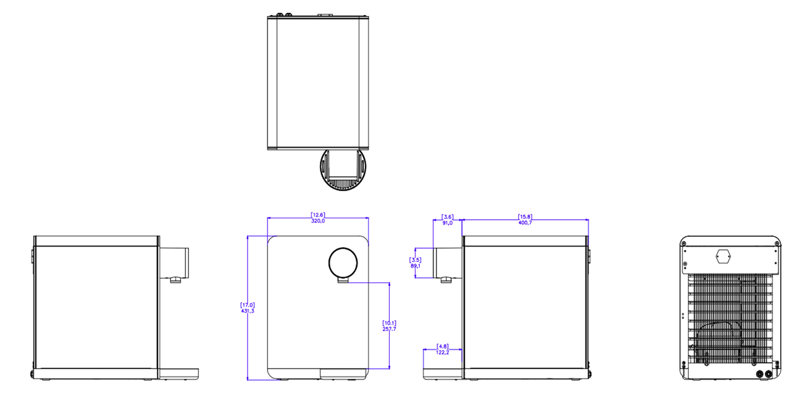
CULLIGAN PURITY ESSENTIAL
Pressurized CT
Single-phase supply voltage +/- 10% | 220V-240V 50Hz/60Hz
Max electrical consumption | CH 933W - 10A  CA 133W - 10A
Hot electrical consumption | 800W
Cold electrical consumption | 100W
Control Units electrical consumption | 20W
UV Lamp electrical consumption | 13W
Refrigerant gas | R600a
Operating pressure | 0.5 – 3 bar
Filtration options | Carbon configuration
Cold Water Capacity | 1.5 L
Hot water capacity | 1.5 L
Temperature Min – Max* | 2ºC - 93ºC
Dispense flow rate | 2L/min
Dispensing length (mm) | 258
Net weight | 15.8 Kg
Gross weight | 17.6 Kg
Dispenser dimensions WxDxH (mm) | 320 x 523 x 431

Packaging dimensions WxDxH (mm) | 340 x 543 x 451
Warehouse storage max humidity | 60%
Sanitization | Firewall Optional
Cold electrical consumption | 800W
Antimicrobial BioCote® | Drip tray  Nozzle Shield  Drip Tray Grill
Leak Detection | Located in the base of the unit and drip tray
Leak Stop | Inlet solenoid valve controlled
Connectivity | IoT with GPRS, NFC and Wi-Fi
Climate Class | N, T
* rated at a room temp. of 25°C and inlet water temp. of 20°C
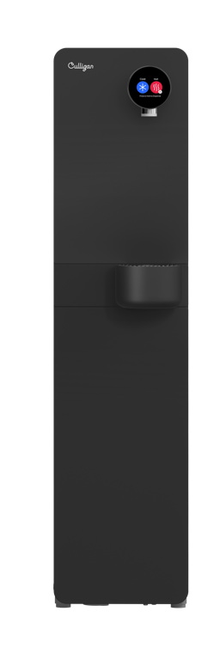
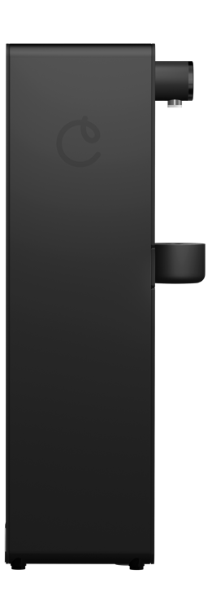
1
2
3

Component Specification

Front view

No | Description
1 | User Interface
2 | Dispense faucet
3 | Drip tray

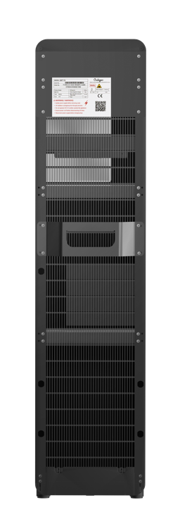
1
Rear view
No | Description
1 | Power socket
2 | Lifting handle
3 | Water Inlet connection
4 | Drip tray waste
4
3
2
Notice of safe usage
Warnings in case of maintenance work
- The first glass of water dispensed after the night break or after a break of at least 10 hours may not be satisfactory due to inactive time. For best results, dispense and discard at least one glass of water for each type of water that can be dispensed, before drinking it.
- Keep out of the reach of children or people who have not received instructions regarding the warnings or correct use.
- Lower performance of the dispenser in terms of cooling should be considered normal when the water temperature is high, for example when the water pipes are exposed to the sun, or due to the increase in water temperature during summer.
- Use the system in a well-ventilated area.
- During use, the system must remain upright. Otherwise, it may not work properly.

Packaging and checks
It is delivered in a cardboard box. When handling the box, always maintain the unit in the upwards positioning.

The packaging must be intact on arrival:
- There must be no signs of impact or breakage
- There must be no signs that it has been exposed to heat, frost, water, etc.
- There must be no signs of tampering
- Any deformation indicates impacts during transport, which could compromise normal operation of the machine.

Machine and equipment check
The machine, its main body, accessories and, more generally, the equipment, must be in perfect condition.
The supply undergoes a careful inspection procedure before shipment; however, it is always advisable to check that it is complete and intact upon receipt of the material.
ATTENTION: in case of defects and/or missing material, notify Culligan immediately and follow the instructions before commissioning the system.
ATTENTION: keep the packing materials for any future shipment of the equipment to the Service Centres.

Product identification data
The data plate on the back of the machine has the machine identification data.

The data plate specifies:
- Model, serial number, power supply voltage (V), frequency (Hz), absorption (A) and the climatic class;
- The type of refrigerant and quantity in grams;
- The country of origin;
- The importer into the UK, Switzerland and European market
- The CE conformity mark

ATTENTION: the removal or any damage to the label identifying the product voids the warranty. The label is the only means of identifying the product, therefore it must remain intact.

The recipients of this publication can be identified as follows:
- Qualified technicians or operators directly involved in the transport, storage, installation, routine and extraordinary maintenance of the machine, from its placing on the market to the day of scrapping.

The original text of this publication, written in English, is the only reference for settling any interpretative disputes regarding the translations of EU languages.
This publication is an integral part of the machine and gives all the instructions for installation and maintenance. Any use of the equipment not covered by this manual is deemed improper use. If some instructions or procedures are not clear, please contact the Culligan Service Centre.
This manual must be kept for future reference until final dismantling or scrapping of the machine
Pre-installation instructions
Warnings during installation

- Ensure all Local, State, and Federal Laws and Codes including health and safety guidelines are met when installing Culligan Equipment. Only qualified service technicians should attempt installation and service of Culligan Equipment.
- The product can be installed in the following places: indoor environment.
- Do not place objects on the water dispenser.
- The installation must be carried out only by qualified and authorized personnel, and with the best state of the art in compliance with what is reported in the technical manual.
- Do not place the dispenser on other objects.
- Check that the machine is well levelled and that it rests on a floor or surface capable of supporting its weight and in an environment suitable for its size and use.
- Before any maintenance or cleaning operation, unplug the machine from the power outlet or disconnect the power supply.
- Installation in outdoor environments exposed to rain or snow is prohibited. Check all relevant parameters (ambient temperature, electricity, water mains pressure) before installation, making sure that all parameters are in line with the technical requirements of the product and in line with the applicable local regulations.
- The machine is not suitable for installation where there are jets of water for cleaning.
- Do not place the machine near sources of heat, flames or the like and damp surfaces
- The dispenser must be placed on a flat, level and dry surface with an adequate capacity for the weight of the product.
- Maximum temperature of the installation environment 32 °C.
- The area chosen for installation must be clean, dry and ventilated, with the equipment placed away from heat sources.

WARNING: during handling or maintenance, always keep the machine in a vertical position. The machine can only be tilted to the rear. Do not tilt or lay the machine on its right, left or front side. This operation could compromise the operation of the compressor.

WARNING: Never leave the product unattended when children and/or animals are around. The product may be put out of balance and may fall, hurt or in worst case even cause fatal injuries. Mount the product on a floor stand that meets the minimum requirements for stability
WARNING: electrical shock hazard. Always unplug (isolate from power supply) to prevent electrical shock except where electrical tests are specified.

WARNING: improper supply or connection can result in risk of shock. always use a dedicated and properly earthed outlet. Unit should be protected by ground-fault circuit interrupter and residual current device (RCD) having a rated residual operating current not exceeding 30 mA;
WARNING: use only Culligan supplied power cord. Locate system within 1m of power supply. Never use an extension cord or adapter. Do not use a damaged power cord or plug. Keep power cord out of heavy traffic areas and away from heat sources. Do not, under any circumstances, remove ground prong or alter the power cord. Never pull the power plug from the outlet with a wet hand or allow the plug to get wet
WARNING: use a water pressure regulator. Culligan will not be responsible for injury or damage caused by excessive water pressure. Operating pressure must be 1 Bar to 3 Bar (14.5 psi to 43.5 psi – 0.1MPa to 0.3MPa).

WARNING: use UV stabilized supply lines. Feed the unit with a potable ambient or cold water supply only. Feed water over 37ºC (98.6ºF) can damage the treatment components. Water block devices and external leak detectors are strongly recommended. Locate the unit as close to the water supply and the electrical connections as possible.

WARNING: UV-C emitter (UV Lamp): this appliance contains a UV-C emitter (UV Lamp). UV-C radiation may, even in little doses, cause harm to the eyes and skin. Never operate the UV-C emitter if damaged or removed from enclosure. Do not touch or look directly into the faucet. The replacement of the UV-C must be done by Culligan or approved Culligan distributors and with power supply disconnected. The UV lamp must be replaced at 6 month intervals or when necessary.

CAUTION: hot water: Culligan machines produces hot water (model dependent) above 52°C (125,6 ºF) and up to 92°C (197,6ºF) which can cause severe burns or scalding. Keep unauthorized people and children away from the unit to avoid accidental dispensing of hot water.

WARNING: store unit empty. Always sanitize before use.
The unit must be completely drained and sealed before storing to avoid stagnation and reduce microbiological contamination (potential bacterial growth). Sanitize before use to eliminate any potential microbiological contaminants.

NOTE: installation and connection must be performed by a Culligan technician. It is prohibited for the end user to access the service area inside of the machine except for filter replacement.
WARNING: A Culligan Technician must connect the water cooler to the mains water supply, you will need to use a new set of connectors (joints, gaskets and pipes).

WARNING: One of the connectors that a Culligan Technician will need is an Install Rail. It is required to use an installation rail for the installation of any Culligan Water Treatment System. Failure to use an installation rail can result in damage due to excessive pressures over a prolonged period of time and no additional leak protection. Please check local water bylaws, in some countries an installation rail is a legal requirement. Not provided with the equipment, but mandatory

Environmental characteristics
The intended operating environment must have the following characteristics:
- Temperature: +16ºC (61ºF) / + 32°C (90ºF)
- Maximum relative humidity: below 60%

The dispenser cannot be used in open areas and/ or exposed to atmospheric agents, or places with corrosive and/or abrasive powders, vapours or fumes, with risk of fire or explosion, and, in any case, where the use of explosion-proof components is prescribed.

Never exposed to direct sunlight, heat sources, or ambient air temperature above 32ºC (90ºF) or below 16ºC (61ºF). Install indoors and keep unit away from excessive humidity. Never expose to freezing temperatures. Ensure there is adequate clearance around the unit to allow refrigeration system condenser to dissipate heat. Warmer environments require more clearance around the unit. Minimum clearance around all surfaces of the machine is 10 cm for proper heat dissipation and efficient operation. Before each installation the product must be sanitized by an authorized technician.

ATTENTION: if environmental conditions other than those prescribed are encountered during installation, or if they undergo variations over time, the Culligan Assistance Centre must be contacted immediately before using the dispenser for the necessary checks.

Please look at the technical specifications and operating limits at the Description of the Unit Chapter to ensure that the location where the unit will be installed fulfils the installation requirements in terms of environmental temperature, mains pressure among other operation requirements.

Operation/Operating
User interface explanation “How To” Safe Usage
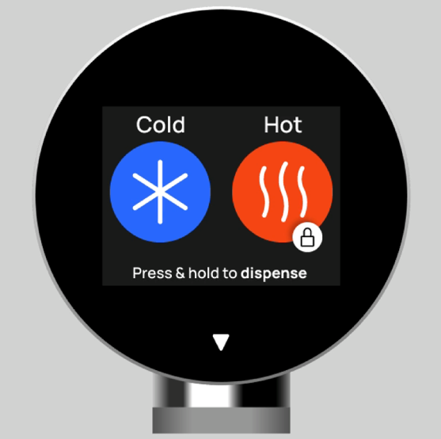

To dispense cold, press and hold. The LED light ring on the faucet will display purple, this indicates Firewall purifying and when the LED light ring turns blue, cold water will dispense.

To dispense hot, press and hold to unlock the safety lock, you will see a white progressive bar circulating the hot icon. The LED light ring on the faucet will display red and hot water will dispense.

Do’s and Don’ts
Do not use any sharp or heavy objects to attempt to dispense from the user interface, this will cause damage and exposure to circuit boards. Please carefully press the touchscreen with your hands.

Filters

Culligan Purity Essential models are water dispensers designed for the delivery of food-grade filtered still water, hot, extra hot, chilled or ambient temperature, combined with the Culligan filtration system.

The standard filtration system has been designed to resolve the common problems of water quality, ensuring the elimination of microplastics as well as of unpleasant odors and flavors caused specifically by the presence of chlorine. Please contact Culligan Customer service to get more information about our filter solutions for the best performance and experience with our product.

The operating limits and the filter specifications are shown on the technical data sheet supplied with the filtration manufacturer.

RO waste
(only required for RO)
Filter cartridge
Sump
Maintenance
ATTENTION: this equipment requires regular maintenance in order to guarantee the potability requirements of the treated water and the maintenance of the work and quality standards declared by the manufacturer.

Important
- For reasons of safety and compliance with regulations, repairs and maintenance must only be carried out by a qualified technician or at a Culligan Service Centre.
- In case of malfunction, do not manipulate or tamper with the internal parts of the device. Contact the Culligan Service Centre.
- In case of a fault, disconnect the power and contact the Culligan Service Centre.
- Interventions not specified in this manual must only be carried out by specialized personnel or Culligan Service Centre.
- Lack of maintenance can result in breakage or deterioration of the pipes, even causing bacterial growth.
- No responsibility is assumed for interventions not covered by this manual. In case of such interventions, the warranty may be revoked. Interventions that may be necessary and not specifically indicated in the manual can only be carried out by the Culligan Service Centre.
ATTENTION: all maintenance operations must be carried out with the dispenser turned off and the water feed and power disconnected. Make sure to unplug the equipment. Interventions on the dispenser that are unauthorized and/or performed by unqualified personnel during the warranty period will automatically void the warranty.

- The following activities are to be carried out daily by the Food Safety Operator from where the unit is installed:
Empty and clean the drip tray. Sanitize the dispensing spout daily by spraying the product (e.g., Cleaning Safe) as instructed in the dedicated section.

The scheduled routine maintenance will be carried out by the Culligan Service Centre or an authorized Culligan Centre.
NOTE: for daily cleaning of the system, only use a disposable paper cloth and a sanitizing detergent for food use. Do not use cloths or sponges already used for other household cleaning, even if they are food-grade. Used sponges, cloths, or unwashed hands can cause contamination of the dispensing spouts of the system and compromise the quality of the dispensed water.

In case of prolonged periods of non-use of the system, contact the Culligan Service Centre, which will perform a general check and sanitize the system before putting it back into operation.

Daily care of the dispenser
Materials needed for daily cleaning
- Disposable paper towel
- Sanitizing detergent certified for food contact use

Procedure:
- Clean the exterior of the system
- Rinse and dry with a new paper towel

Materials required for external cleaning
- Disposable gloves
- Disposable paper towel
- Sanitizing detergent for use with food Cleaning Safe Culligan, sanitizing alcoholic detergent without rinsing

Procedure:
- Wash your hands thoroughly and wear disposable gloves
- Empty and clean the drip tray
- Spray the sanitizing product over the entire surface of the system, including taps and spouts
- The product evaporates after a few seconds and does not require rinsing

Shutdown
Temporary shutdown
The machine can remain unused or turned off for an extended period. In such cases, when intending to use it again, proceed as follows:

- if the dispenser has been off/unused for more than 72 hours but less than 5 days, dispense at least 5 liters of water;
- if the dispenser has been left off/unused for more than 5 days, proceed to sanitize the dispenser according to the methods described above.
- Sanitize the dispenser as required;
- The dispenser must be managed in full compliance with the hygiene regulations, to ensure the quality of the dispensed product.
Disposal, Waste and Recyclability

Information to manage electric and electronic equipment waste.

Crossed out wheelie bin denotes that waste electrical and electronic equipment and batteries must not be disposed of as unsorted municipal waste but collected separately. This symbol appearing on the product, batteries, accumulators or package or documentation indicates that the product and batteries or accumulators must not be collected, recovered or disposed of together with household waste at the end of its life cycle.

This unit is marked in compliance with European Directive 2012/19/UE on Waste Electrical and Electronic Equipment (WEEE). By ensuring that the product is scrapped correctly, you are helping to prevent potential negative consequences for the environment and for health. The symbol on the unit indicates that the product should not be treated as domestic waste but should be taken to a
dedicated recycling centre for electrical and electronic equipment.

The disposal of materials (waste and exhausted) must also be done in full compliance with all current environmental regulations. Consumables, such as cartridges and filter materials, deriving from maintenance at private customers, must be transferred to the undifferentiated collection directly by the customer; on the other hand, for materials deriving from maintenance at companies, the contractual agreements between the parties and the procedures for attributing the CER code and disposal required by current environmental legislation must be respected

For more information on the treatment, recovery and recycling of this product, please
contact the appropriate local office, the waste disposal service or the reseller from which
the product was purchased.

Packaging materials
The packaging materials are 100% recyclable. Please recycle each material at the proper bin. Please follow the local guidelines on waste disposal. For safety reasons keep the packaging material out of the reach and sight of children.
Packaging is made of environmentally friendly materials, which may be disposed of through your local recycling facilities. By disposing of the packaging and packaging waste in the proper manner, you help to avoid possible hazards for the environment and public health.
NOTE: see relevant information related to refrigerant gas safety in the Warnings chapter for information on the natural, eco-friendly refrigerant gas used in this cooler

Recycling guidance
Please ensure you follow the correct guidance for recycling and disposing of all components of the unit. Scan the QR code below to access detailed recycling information.

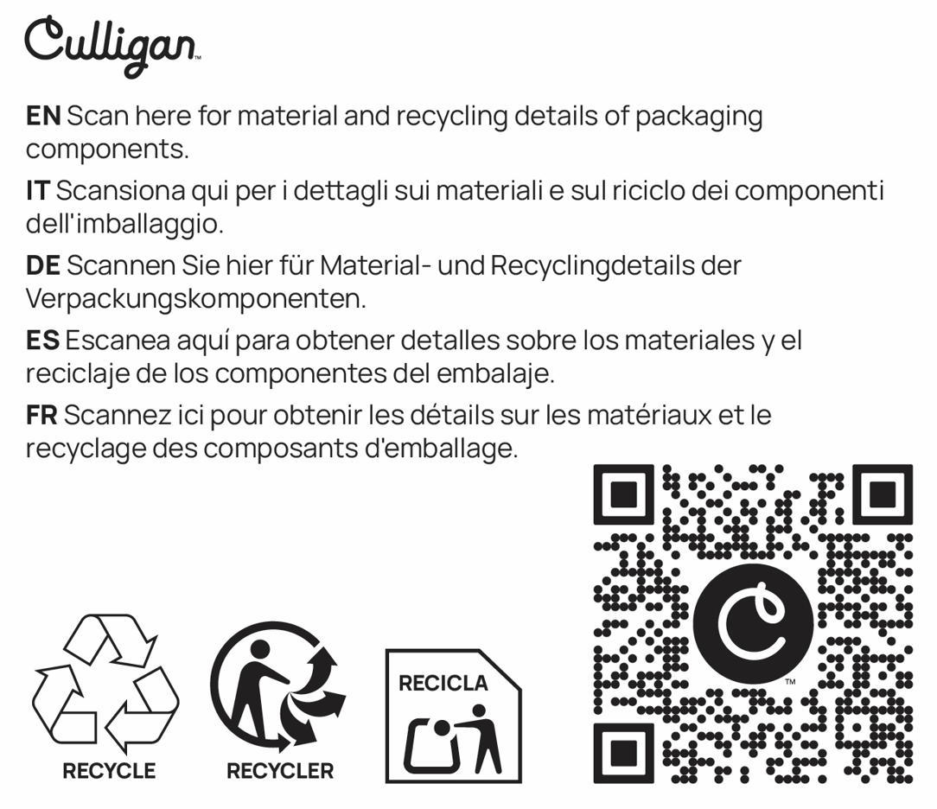
FAQ
Installation & Setup
Q: Who do I need to install my Culligan Purity?
A: Culligan will carry out the installation for you from our professional technicians.
Q: What are the space requirements?
A: To install your Culligan Purity, we will need access to a water supply and a power outlet. A small clearance space is also needed for ventilation and maintenance access. Please see the Culligan Purity user manual for more information.
Q: Can it be installed in any location?
A: To maximise the use of the Culligan Purity, it should be installed indoors near a potable water source, power supply, and, if necessary, a drainage point for wastewater.
Operation & Features
Q: Does it provide both hot and cold water?
A: Yes, all our models provide hot and cold water but we also offer sparkling, ambient and extra hot in our best-in-class Prime model.
Q: Is the water filtered?
A: Yes, the Culligan Purity includes built-in filtration to remove microplastics, impurities, chlorine, and unpleasant tastes or odours.
Q: How long does it take to cool or heat water?
A: Cooling and heating are typically instant after the initial setup, as the water is stored in temperature-controlled tanks, when you use cold or hot water, the unit will replenish what is used.
Maintenance & Care
Q: How often should the filters be replaced?
A: The Culligan Purity is connected to the Culligan One cloud system and therefore we are always checking and monitoring the health of our units 24 hours, 7 days a week. This means, when filters are nearing their time to be replaced, we will contact you to provide you with complete peace of mind.
Q: How do I clean the cooler?
A: Regular external cleaning with a soft cloth and mild detergent is recommended. All internal cleaning and sanitation will be conducted by Culligan during the maintenance visit.
Q: Is maintenance and servicing required?
A: Culligan will provide you with all of the products maintenance and servicing needs. With the unit being connected to the Culligan One cloud system, we are always checking and monitoring the health of our units 24 hours, 7 days a week. This means, when the unit needs to be serviced, we will contact you to provide you with complete peace of mind.
Safety & Compliance
Q: Is the hot water child-safe?
A: All of our models feature a safety lock system on the hot water to prevent accidental use.
Q: Does it meet health and safety standards?
A: All of the Culligan Purity models comply with relevant water hygiene, mechanical and electrical safety regulations.
Troubleshooting
Q: The water isn’t dispensing – what should I do?
A: Check that the unit is plugged in to the power source and the power source is on, the water supply is on, and that there are no kinks in the tubing. Refer to the user manual or contact customer support for additional help.
Q: The water tastes strange – is this normal?
A: This can happen shortly after a filter change or installation. Run several litres through the system, this will remove any taste that may be evident from the cleaning process. If the problem persists, contact customer support for help
Q: My cooler is making a noise – is that normal?
A: Some noise is normal during heating and cooling. Persistent or loud sounds could indicate a need for maintenance or inspection, in this event, please contact customer support for help.

